Track-Weighted Dynamic Functional Connectivity (TW-dFC) method script

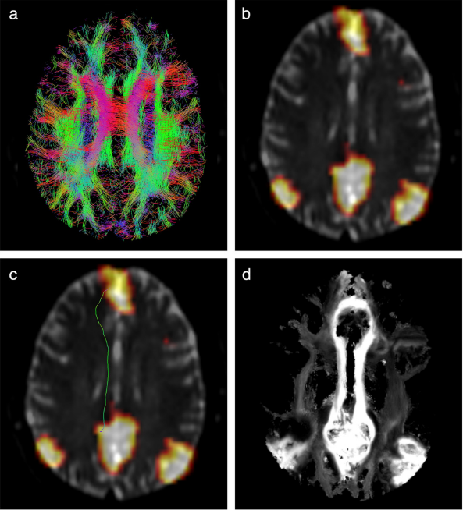

In this pipeline, you will be doing a joint structural connectivity (SC) – functional connectivity (FC) analysis. You will be generating a ***track-weighted image (TWI)***, which combines the tractogram (SC) with the functional image or map (FC). We are interested in how well the SC and FC correlate with one another, as it has been shown the SC and FC are facilitated / guided by one another (Honey et al., 2009). Essentially, this method looks at how well the FC (i.e. resting-state network (RSN) is weighted by the SC (i.e. white matter fibre tracts from the tractogram). This technique has been developed by (Calamante et al., 2013; Calamante, Smith, Liang, Zalesky, & Connelly, 2017) and is utilised in MRtrix3 (Tournier et al., 2019).

**Requirements:** Preprocessed / cleaned dwi + anat, and fMRI data, white matter group normalisation template, whole-brain tractograms per each participant (with anatomically-constrained tractography (ACT) and SIFT), fMRI RSNs (e.g., via FSL ICA MELODIC). It would be good to run the following scripts / pipelines, prior to this: Preprocessing.m, CSD.m, Connectome.m, fmriprep, recon-all. See below for the data acquisition, parameters, and preprocessing that Calamante used.

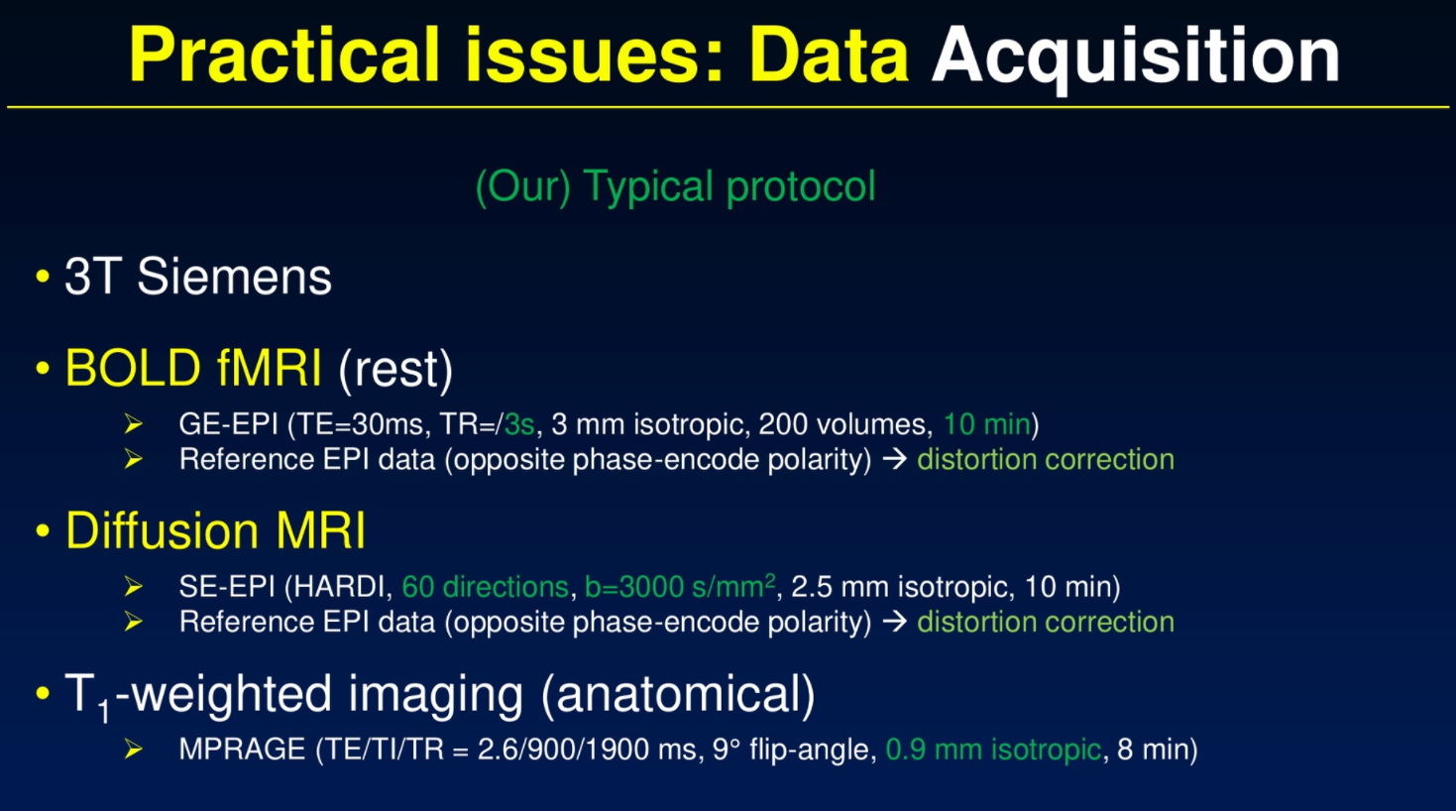

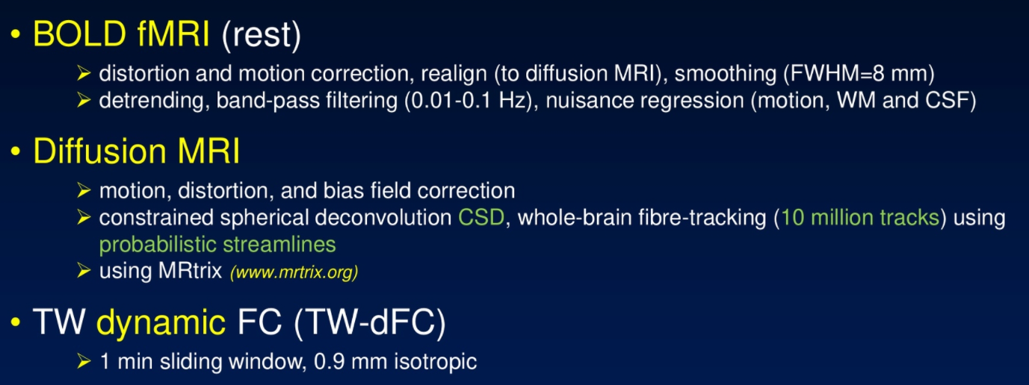

Steps:

Pre-steps – have all of the requirements, as specified before.

1. Co-register T1w with dwi
   1. Create the transformation matrix for T1w and dwi B0 co-registration
   2. Apply linear transformation matrix to the T1w image
   3. Convert the co-registered T1w-dwi nifti to .mif file
2. Co-register fMRI BOLD with dwi
   1. Create transformation matrix for the BOLD and dwi B0 co-registration
   2. Generate the co-registered image (co-registered BOLD-dwi image)
   3. Convert the co-registered BOLD-dwi nifti to .mif file
3. Warp individual track files to group FOD template
4. Investigate a specific network (TW-FC / TDI)
   1. Create individual template maps for track-weighted functional connectivity (TW-FC) image
   2. Use track data + T1w to form a high-resolution image (TDI) for TDFC template
5. Investigate whole-brain dynamic functional connectivity (TW-dFC)
   1. Create the track-weighted dynamic functional connectivity (TW-dFC) map per each individual
   2. Create summary image (confidence interval of every voxel) per each individual
   3. Generate a coloured TDI image (DEC option) for reference
6. Calculate group mean TW-dFC template from the normalised individual TW-dFC maps
   1. Generate a coloured TDI image (DEC option) for reference
7. Run GLM analysis for comparing groups
   1. Include BOLD confounds (i.e. nuisance regressors), such as motion and brain artifact regressors, and cosine-basis regressors for temporal high-pass filtering

Regarding the processing pipeline, I want to follow what was done in the Calamante et al., 2013 paper (this is for the TW-FC process, specifically, but the TW-dFC process also follows the same basis) –

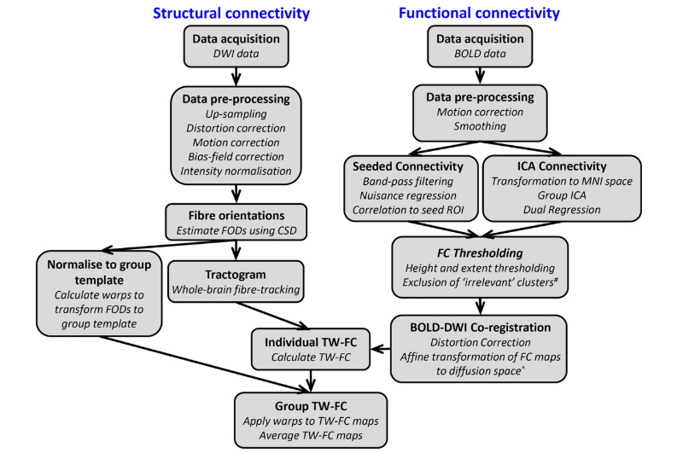

Video: **Track-weighted functional connectivity: structure meets function** (OHBM 2016, Fernando Calamante, The Florey Institute of Neuroscience and Mental Health, Melbourne, Australia)

<https://www.pathlms.com/ohbm/courses/2658/sections/4175/video_presentations/33859>

1. **Co-register T1w (anat) with diffusion (dwi)**

Co-register each participant’s preprocessed anat T1w image (3D) to the cleaned diffusion-weighted image (dwi) B0 (3D) image. This will create a 3D image (combine structural + structural image). Note that if you will be doing group comparisons in the subsequent steps, then you will need to make sure that your T1w image is on standard, common space (e.g. MNI152) between participants.

1. **Create the transformation matrix for T1w and dwi B0 co-registration**

Linear registration with 6 degrees of freedom (dof) are used. Do this registration with both the t1w and t2 FLAIR images to the dwi image (first b0 vol in dwi sequence - captured as the ‘bestb0’ from the previous script).

Command: flirt (fsl)

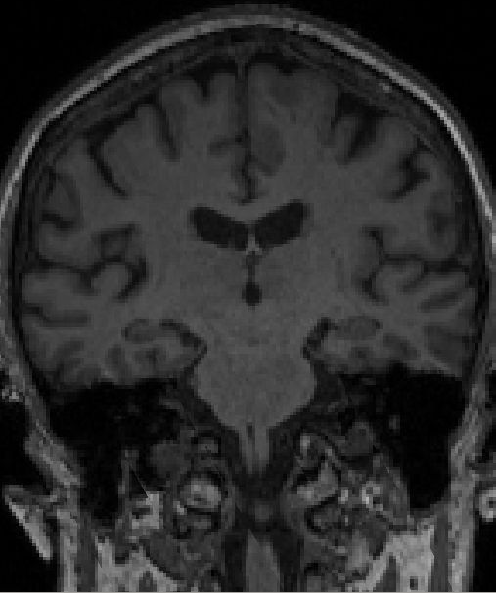 **+** 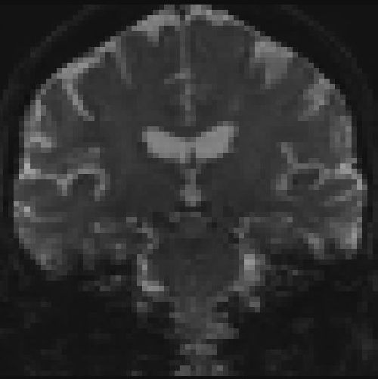

T1w dwi (b0)

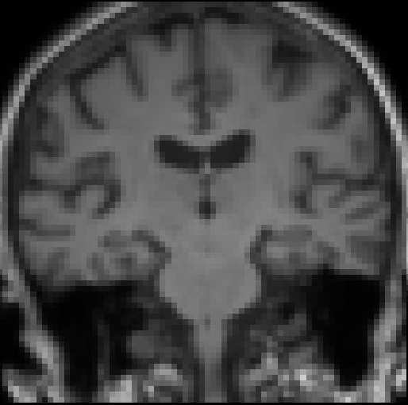

Co-registered (t1_flirt)

1. **Apply linear transformation matrix to the T1w image**

Once you have applied co-registration using FLIRT, you need to create linear transform matrices to apply to the images. This is because by default, FLIRT applies a direct *resampling* of the input image to match the target image, which is unnecessary. It is better to have flirt provide the calculated transformation matrix, then *apply* that linear transformation to the T1 image (either using flirt again, or combination of transformconvert and mrtransform), such that the image header transformation is altered but the image grid / intensities are not.

Command: transformconvert

mrtransform

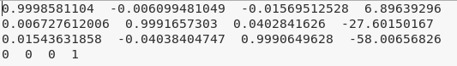

*transform_flirt_t12dwi.mat*

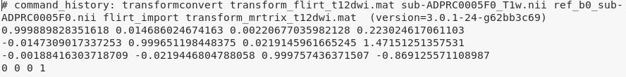

*transform_mrtrix_t12dwi.mat*

See posts on mrtrix community forum for more info: <https://community.mrtrix.org/t/5ttgen-error/1138>; <https://community.mrtrix.org/t/5ttgen-waiitng-for-creation-of-new-file/1044/2>

1. **Convert the co-registered T1w-dwi nifti to .mif file**

Command: mrconvert

1. **Co-register fMRI BOLD with dwi**

Co-register each participant’s preprocessed BOLD fMRI image (4D) to the cleaned diffusion-weighted image (dwi) B0 (3D) image. This will create a 3D image (combine the structural image with the BOLD). Note that if you will be doing group comparisons in the subsequent steps, then you will need to make sure that your BOLD image is on standard, common space (e.g. MNI152) between participants.

1. **Create transformation matrix for the BOLD and dwi B0 co-registration\***

%Sample input: sub-ADPRC0001F0_task-rest_run-1_boldref.nii.gz *(preprocessed BOLD fmri image)* *&* ref_b0_sub-ADPRC0001F0.nii *(reference dwi B0 image – 1 vol)*

Command: flirt

%Sample output: flirt_bold_sub-ADPRC0001F0.nii.gz (*image*) *&* bold2b0_sub-ADPRC0001F0.mat (*martrix*)

* note that the flirt_bold output image will not be used as input for tckfdc, but it is only being used here to generate the transformation matrix in order *coregister* the dwi and fmri images together.

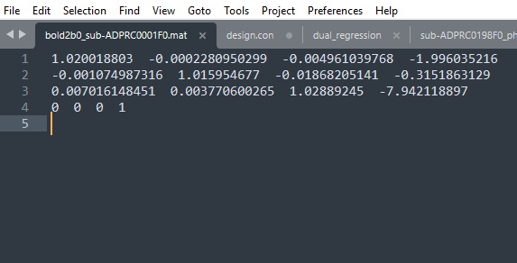

fMRI BOLD and reference b0 dwi transformation matrix.

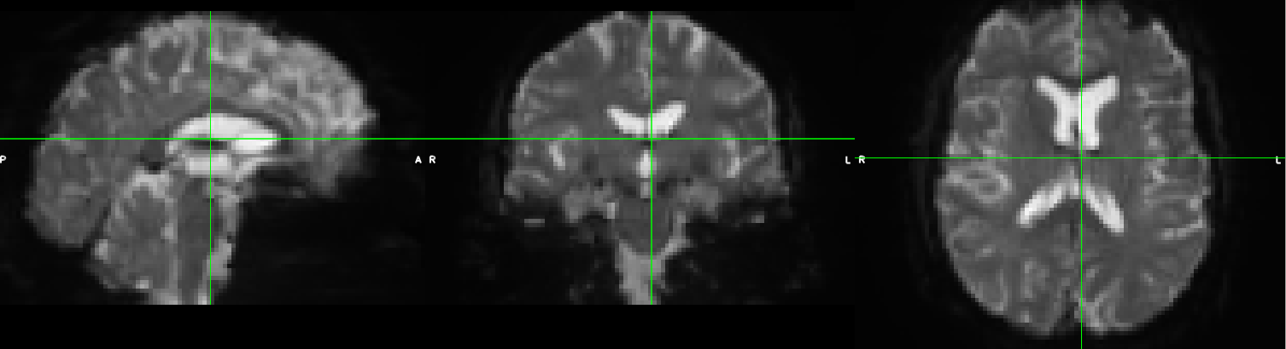

This is the flirt_bold_sub-ADPRC0001F0.nii.gz file – the combination of the fmri BOLD with the reference b0 diffusion image. This image is only used to generate the matrix, as shown above, and for the subsequent steps.

1. **Generate the co-registered image (co-registered BOLD-dwi image)**

Create the co-registered image by applying the transformation matrix (generated from the prior step) to the BOLD fmri and dwi reference b0 images together.

%Sample input: sub-ADPRC0001F0_task-rest_run-1_desc-preproc_bold.nii.gz *(preprocessed BOLD fmri image),* bold2b0_sub-ADPRC0001F0.mat *(transformation matrix), &* ref_b0_sub-ADPRC0001F0.nii *(reference dwi B0 image – 1 vol)*

Command: flirt

%Sample output: bold_coreg_sub-ADPRC0001F0.nii.gz (*coregistered BOLD fmri + dwi image*)

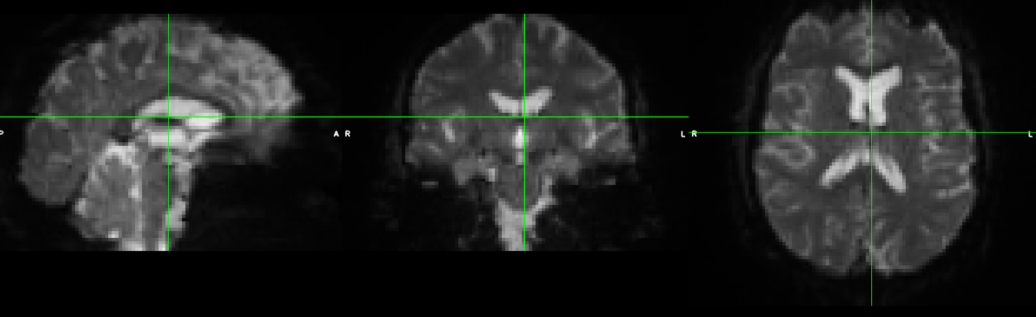

This is the bold_coreg_sub-ADPRC0001F0.nii.gz file – the coregistered combination of the fmri BOLD with the reference b0 diffusion image. Looks like this image is bias field corrected, compared to the prior image.

1. **Convert the co-registered BOLD-dwi nifti to .mif file**

%Sample input: bold_coreg_sub-ADPRC0001F0.nii.gz *(coregistered BOLD fmri + dwi image)*

Command: mrconvert

%Sample output bold_coreg_sub-ADPRC0001F0.mif *(.mif format)*

More information about the co-registration between the fMRI BOLD and dwi: <https://community.mrtrix.org/t/tckdfc-question/2522>

1. **Warp individual track files to group FOD template**

Individual tractograms must be normalised to a template (wmfod_template) using warps computed by symmetric diffeomorphic non-linear registration of the FODs obtained from CSD (Raffelt et al., 2011). TDI maps can then be calculated from the normalised tractograms.

1. **Use the wmfod group template generated from CSD pipeline**
2. **Normalise individual tractograms to wmfod group template using FOD warps obtained from CSD**

Command: mrregister -nl_warp_full

warpconvert warpfull2deformation

tcktransform

More on warping tracks to template: <https://community.mrtrix.org/t/applying-warp-to-tck-file-with-tcktransform/3111>

MRtrix wiki page: <https://community.mrtrix.org/t/registration-transformation-regridding-concepts/3684>

Example with a subject (I modeled my script from here): <https://gist.github.com/maxpietsch/0085181a263e276139a93c3a0a1a00b5>

For using warps from other packages: <https://community.mrtrix.org/t/registration-using-transformations-generated-from-other-packages/2259>

1. **Investigate a specific network (TW-FC / TDI)**

There are two options for generating a track-weighted image – either the track-weighted functional connectivity (TW-FC) image or the track-weighted dynamic functional connectivity (TDFC) image, which are with a specific network defined or without a specific network defined (whole-brain analysis), respectively. The functional connectivity will be relying on (aka weighted on) the white matter fibre tracts. See below for more details on this.

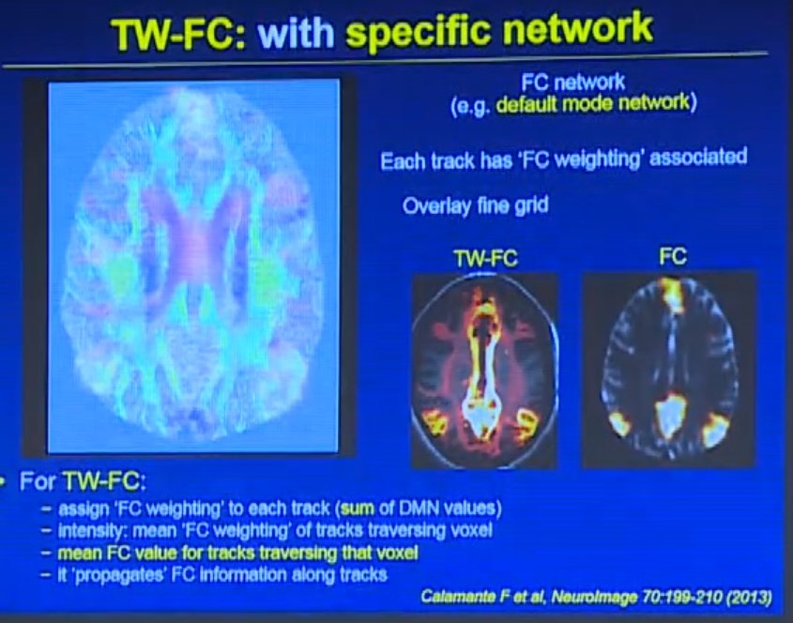

You are mapping the functional data into the pathways (track-weighted). In the TW-FC figure, it is showing that the higher the intensity is (i.e. brighter yellow), then there are more fibre tracts connecting between the RSN regions (in this case, the default mode network (DMN)). So then, the TW-FC (a single image) contains information for both structural and functional data.

1. **Create individual template maps for track-weighted functional connectivity (TW-FC) image**

%Sample input: sift_1M_sub-ADPRC0001F0.tck *(1 million tracks, which have been ‘sifted’)*, sub-ADPRC0001F0_T1coreg.mif *(anat-dwi coreg image)*

Command: tckmap - template T1w image

%Sample output tdi_sub-ADPRC0001F0.mif *(track-density image)*

1. **Use track data + T1w to form a high-resolution image (TDI) for TDFC template**

Generate a track-weighted functional connectivity (TW-FC) image with a defined specific network. For my study, I am interested in looking at the frontoparietal network (FPN), and I will be using a defined template map for this.

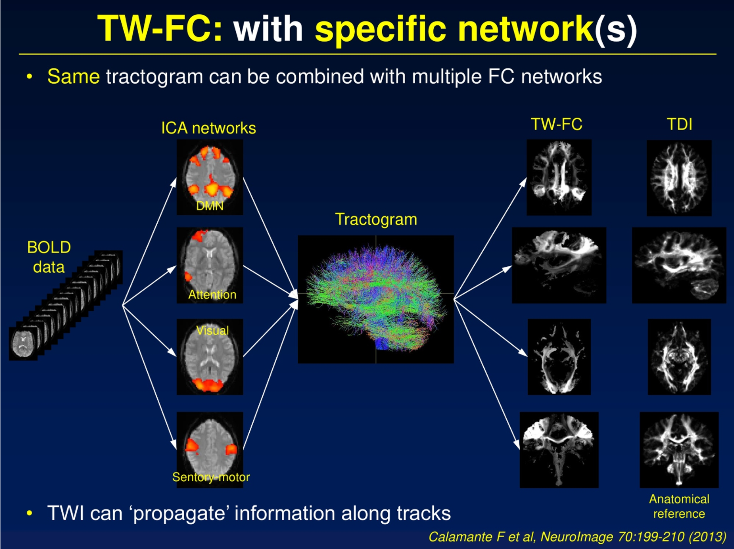

Looking at ***specific networks*** with using ICA and then using the same tractogram.

Read here for more information on this process: <https://community.mrtrix.org/t/generating-track-weighted-functional-connectivity-tw-fc-maps/2545>

1. **Investigate whole-brain dynamic functional connectivity (TWdFC)**
2. **Create the track-weighted dynamic functional connectivity (TW-dFC) per each individual**

Generate a track-weighted dynamic functional connectivity (TW-dFC) image without a specific network. Essentially, you are looking at the dynamic functional changes (BOLD) in the whole brain via the track end points (dwi).

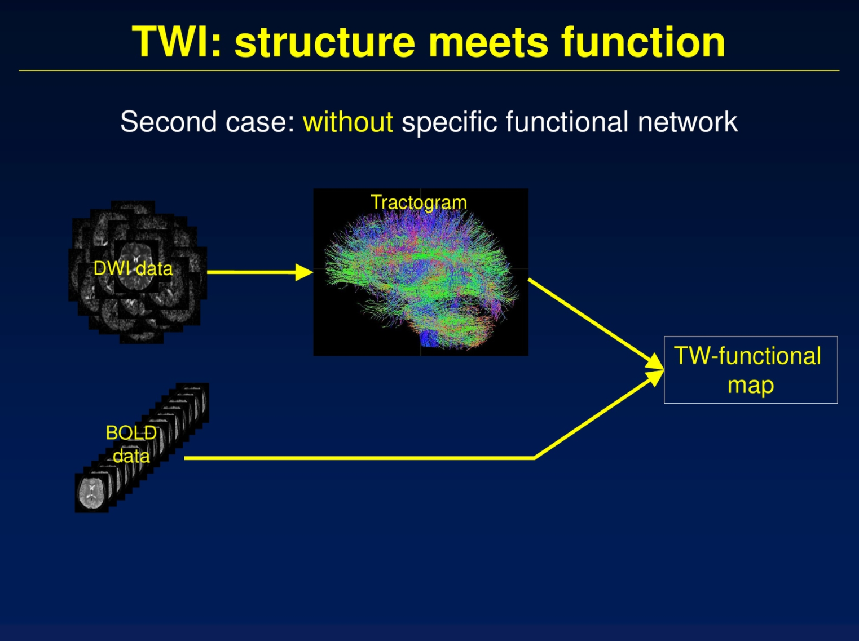

Do TW-FC ***without a specific network***; look at the whole-brain without a specific network. Whole-brain analysis instead uses the ***endpoints of each of the tracts*** for analysis (see next image for more details).

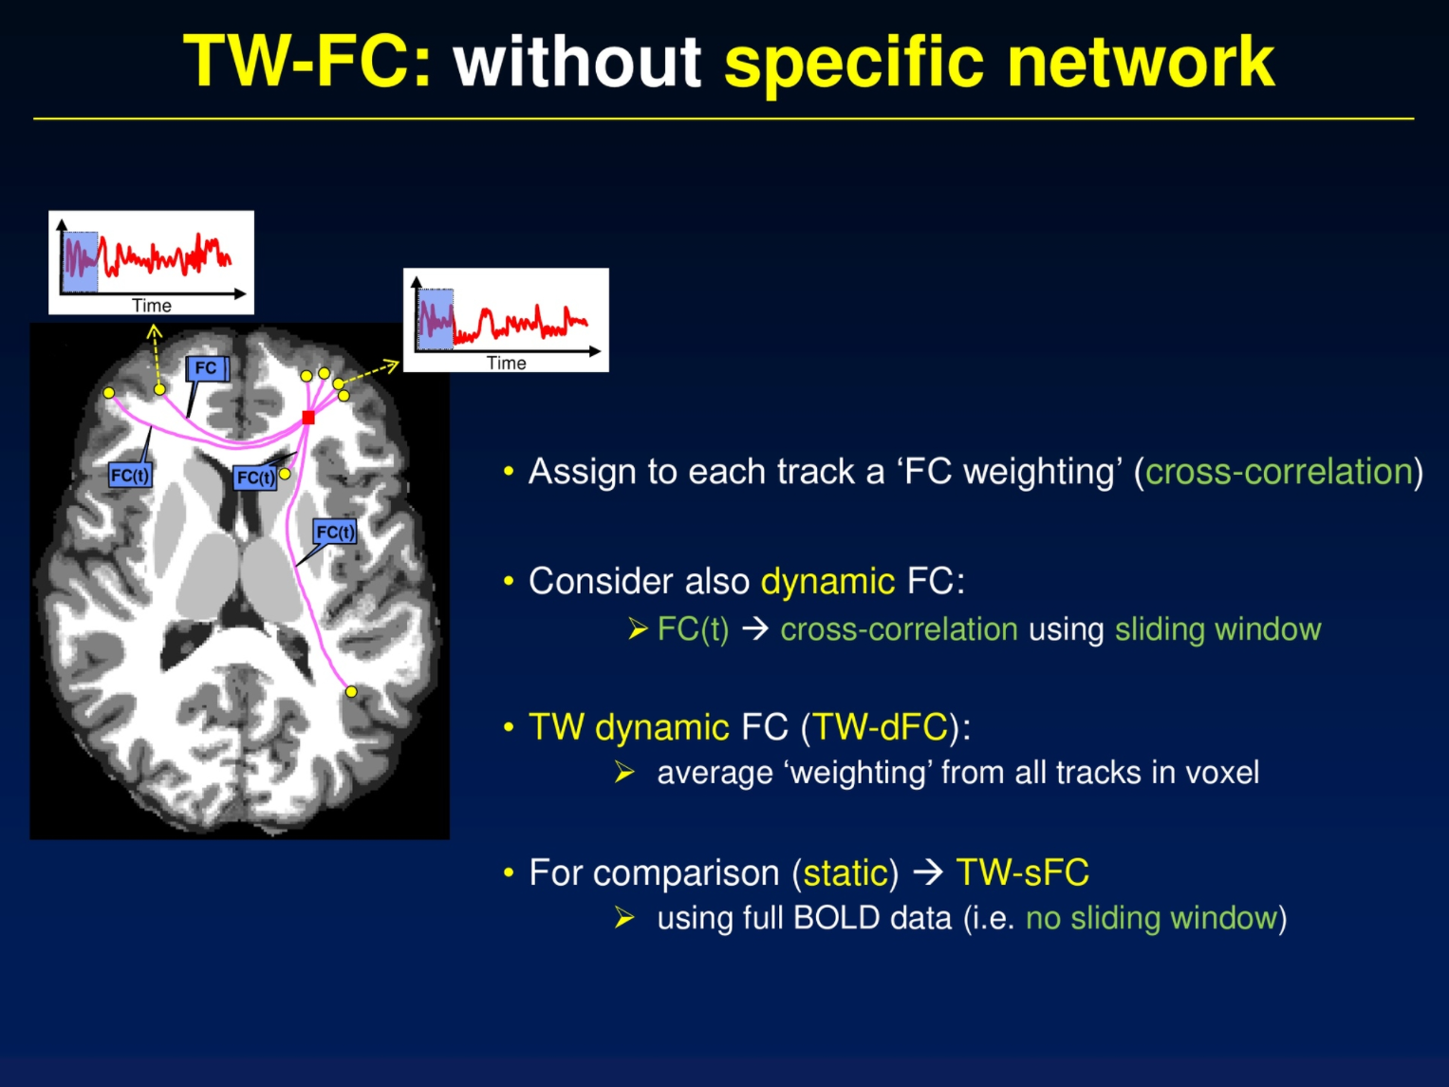

Each tract (from endpoint to endpoint – in yellow circles) is getting assigned a ‘FC weighting’, which is the correlation of the BOLD data between the endpoints (yellow circles), i.e. a Pearson correlation between the fMRI time series at the streamline endpoints. This example is just showing 4 tracts (pink lines) going through one voxel (red box) being connected with the BOLD data. It will correlate the BOLD data between the two track endpoints. It will also take the average ‘weighting’ from all tracks that go through the voxel.

* “Dynamic” functional connectivity (-dynamic option): The output image is a 4D image, with the same number of volumes as the input fMRI time series. For each volume, the contribution from each streamline is calculated based on a finite-width sliding time window, centred at the timepoint corresponding to that volume.

%Sample input: sift_1M_sub-ADPRC0001F0.tck *(1 million white matter tracks),* sub-ADPRC0001F0_T1coreg.mif *(anat-dwi coreg image as template reference),* bold_coreg_sub-ADPRC0001F0.mif *(fmri-dwi coreg image)*

Command: tckdfc -dynamic

%Sample output: tdfc_dynamic_sub-ADPRC0001F0.mif *(track-weighted dynamic functional connectivity – 4D output image, dynamic version)* *

* Note that you may need to reduce the image size if the image is too large for viewing (via mrview); see below for more details.

Do note that the dynamic version of this file is quite large (~25 GB per participant), as it is capturing the correlation between the tracks and FC in every BOLD volume (for this dataset, 490 volumes) and because of its size, it is unviewable in mrview. The resulting dynamic output file has the same number of time points as the input fmri file.

You can reduce the size of the image by having less volumes for the fmri BOLD input – changing the number of track streamlines does not change the size. You also can adjust the shape and width (in volumes) of the image when running this command. A lower resolution of template image (T1w-dwi co-registered image) can also help to reduce the size of the image. For me, a **voxel size of 1.85** has worked, with a 4.08 GB size of the file.

%Sample input: sub-ADPRC0001F0_T1coreg.mif *(anat-dwi coreg image)*

Command: mrgrid regrid -voxel (specify voxel size number)

%Sample output: sub-ADPRC0001F0_T1coreg_vox1.85.mif *(resized image)*

Another option for this is to crop your resulting participant TWdFC image via a its participant brain mask, without image interpolation, in order to retain some more resolution. With this method, a *cropped image* with a **voxel size of 1.4** has worked, with a 3.5 GB size of the file.

%Sample input: tdfc_dynamic_low-res-1.4vox_sub-ADPRC0001F0 mif *(TW-dFC image)*, upsampled_mask_mod-1.4vox_T1coreg.mif

Command: mrgrid regrid -voxel (specify voxel size number)

mrgrid crop

%Sample output: cropped_tdfc_dynamic_low-res-1.4vox_sub-ADPRC0001F0.mif *(resized image)*

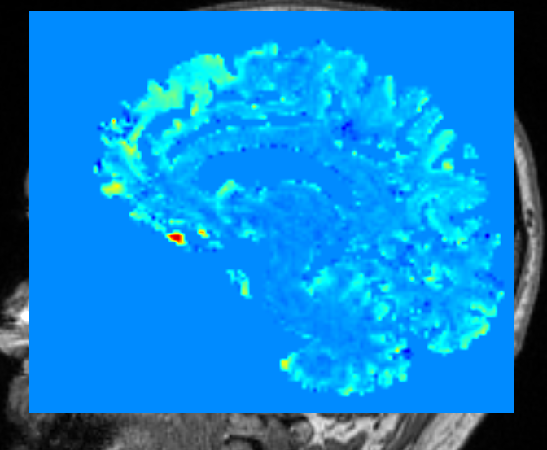

Cropped TW-dFC image (at 1.4 voxels) overlayed on the T1-dwi coregistered image. This option allows for more resolution without the image size being too big. Good for visualisation; for the final analysis, you do not need to reduce the image resolution.

*Sliding windows*

It is also important to consider the size of the sliding window you will be using. In (Calamante et al., 2017) paper, they used a 1-minute sliding window, which consisted of 21 volumes from their dataset. Choosing a sliding window is highly debated in literature, and it also depends on your data, as there is a trade-off between shorter vs. longer window timeframes. In general, this trade-off is that a smaller window will capture more signal, but may also include noise, and vice-versa. With choosing your window length, you want to minimise false positives as best as you can. Based on (Zalesky & Breakspear, 2015), I chose a **1-minute sliding window**. If you have relatively lower signal-to-noise-ratio (SNR), then you can get away with having a smaller time window length. 1 You can also have a choice in the shape of the window - rectangle, triangle, cosine, hann, hamming and lanczos.

Principles of FMRI - Sliding windows: <https://www.youtube.com/watch?v=lV9thGD18JI&t=97s>

Below is an example from one participant’s TW-dFC image (voxel 2.1) overlayed on the anat-dwi coreg image over a time span with a 1-minute sliding window. It is showing the correlation (-0.7 to 0.7) of the fmri BOLD data between the track endpoints for every voxel. *

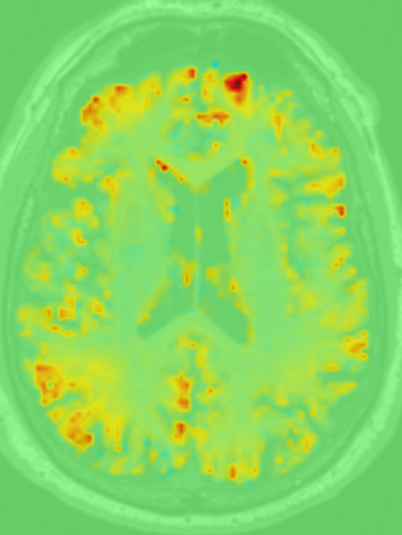 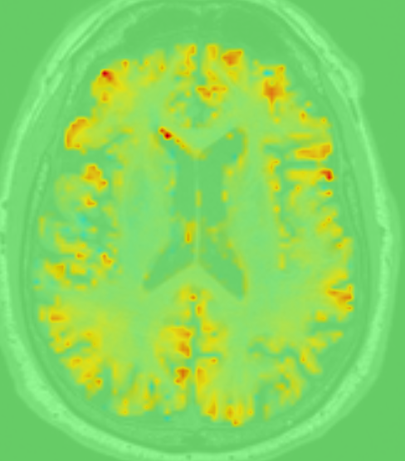 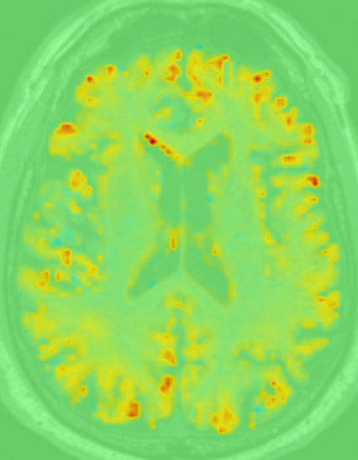 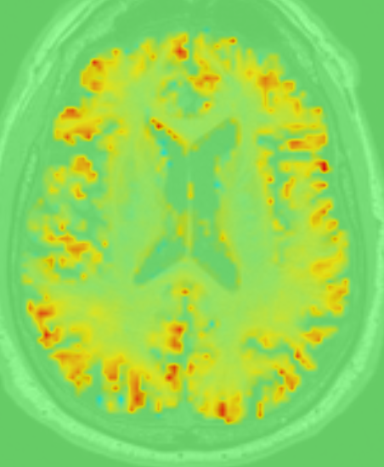 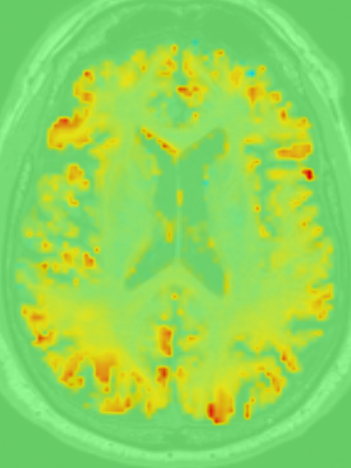

**20 100 180 350 430**

Volumes (over time)

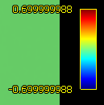

Video file:

(on local computer)

Link (Google Drive)

* For better visualization, you can convert the **0** values from every voxel as NaN, so as to ‘black them out’:

%Sample input: tdfc_dynamic_low-res-1.4vox_sub-ADPRC0001F0 mif *(TW-dFC image)*, upsampled_mask_mod-1.4vox_T1coreg.mif

Command: mrmath

mrthreshold

mrcalc

%Sample output: tdfc_dynamic_nan_low-res-1.4vox_sub-ADPRC0001F0.mif *(the zeros have been transformed to NaNs in this image)*

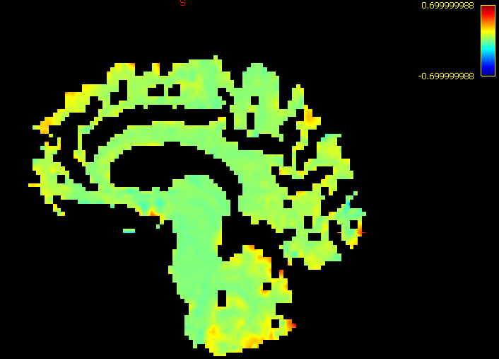

The zero values (0.0) have been transformed into NaNs, resulting in filling them out with the black background. The black areas in this image means that there were no white matter tracts (from the sift 1 million track file) passing through those voxels.

I applied the same concepts from this MRtrix documentation here: <https://mrtrix.readthedocs.io/en/latest/fixel_based_analysis/mitigating_brain_cropping.html>

1. **Create summary image per each individual**

Once you have created your TW-dFC image, you can generate a summary of the correlation variation as one image. To do this, simply plot the confidence interval of the correlation at every voxel. 2 options for visualising the variance in the voxels: *standard deviation*, *standard error*. Standard deviation (SD) is for the variance in your given a sample, and standard error (SE) is for the variance in the sampling distribution (both assume normal distributions). SD may be better for measuring the variance from your study, while SE is more generalised to the population. SE will always be smaller / more conservative than SD. In regards to measuring variance from a distribution which is NOT normal, it would be good to use using *bootstrapping* methods, or some sort of data transformation for this.

Below, I have checked whether the voxel data over time (over 490 timepoints) was normalised.

To calculate the standard deviation (the measured variance from your sample), you can run a one simple MRtrix command which calculates this:

%Sample input: tdfc_dynamic_sub-ADPRC0001F0.mif *(track-weighted dynamic functional connectivity – 4D input image, dynamic version)*

Command: mrmath -std option

%Sample output: tdfc_std_sub-ADPRC0001F0.mif *(standard deviation of every voxel across timepoints - 3D output image)*

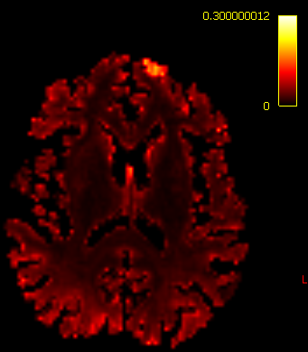

Brighter areas (e.g. fornix, frontal left cortex) indicates higher dynamic fluctuation (via a larger SD) over time. *

*Note that the regions where the SD is zero has automatically been blacked out.

On the other hand, to calculate the confidence interval per each voxel, you will need to run a series of calculations on the voxels across the volumes on the images, as this function is not implemented in MRtrix.

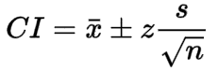

Confidence interval formula.

We will be calculating the confidence for every voxel and then subtracting the lower bound from the upper bound, like what was done in (Calamante et al., 2017).

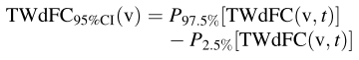

%Sample input: tdfc_dynamic_sub-ADPRC0001F0.mif *(track-weighted dynamic functional connectivity – 4D input image, dynamic version)*

Command: mrmath …

mrcalc ….

%Sample output: tdfc_CI95_sub-ADPRC0001F0.mif *(confidence interval range (i.e. the upper bound minus lower bound) of every voxel across timepoints - 3D output image)*

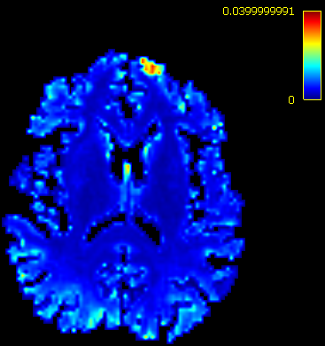

Brighter areas (e.g. fornix, frontal left cortex) indicates higher dynamic fluctuation (via a larger range between the upper and lower bounds of a 95% confidence interval) over time. Notice that this is similar to the SD map, as both are some index of variability over time.

Example from (Calamante et al., 2017):

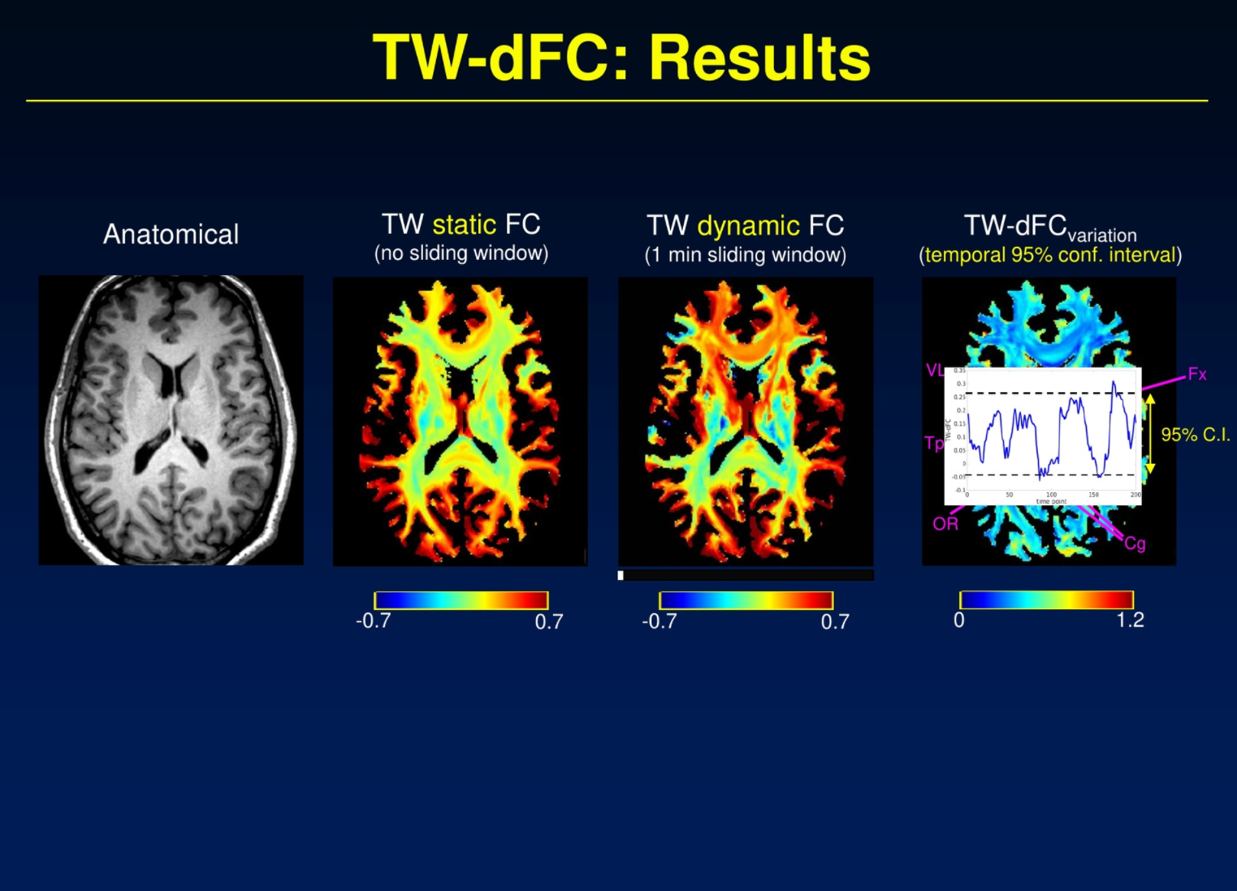

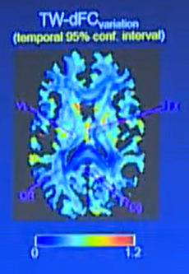

Whole-brain track-weighted functional connectivity, with track-weighted functional connectivity (TW-FC - static) and track-weighted dynamic functional connectivity (TW-dFC). You can either do this with a sliding window (dynamic) or without a sliding window (static). From left to right - **1st image**: anatomical reference – slice through the basal ganglia. **2nd image**: static version – without sliding window. Not so much information. **3rd image**: dynamic correlations showed for 1 min. Strong changes in correlations over time found in the fornix, optic radiation, cingulum (lots of colour changes over time). **4th image** (and on bottom): summary of the changes over time. You can simply do this by plotting the confidence interval at each voxel. Brighter area (yellow-orange-red), exhibit more changes over time. For example, the fornix (in the centre) changes a lot, so there is brighter (more yellow, orange) colour.

1. **Generate a coloured TDI image (DEC option) for reference**

To characterize the magnitude of the dynamic fluctuations in the TW-dFC values in each voxel, you can calculate the 95% confidence interval of the TW-dFC values across the fMRI BOLD volumes (over time). These would be the temporal confidence intervals.

%Sample input: sift_1M_sub-ADPRC0001F0.tck *(1 million fibre tracts, sifted)*, sub-ADPRC0001F0_T1coreg.mif *(anat-dwi coregistered image)*

Command: tckmap -dec option

%Sample output: tdi_dec_sub-ADPRC0001F0.mif *(coloured, high-resolution, track-density image)*

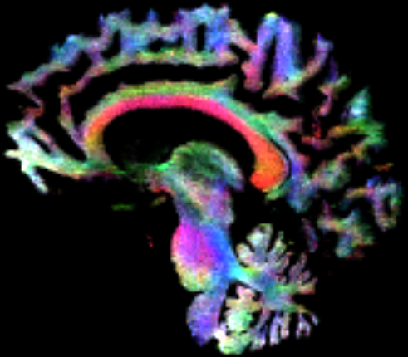

1. **Calculate group mean TW-dFC map from the normalised individual TW-dFC maps**

We will be taking the average across the images in order to make group comparison for the next step. Note that the TW-dFC maps must be in the same, common space (e.g. MNI) in order to make group comparisons – if you wish to do this, you need to do it at the very beginning when co-registering your dwi with fMRI BOLD.

%Sample input: tdfc_CI95*.mif *(selecting all participant tdfc images, with the confidence interval at 95% - 3D image, 1 vol)*

Command: mrmath mean

%Sample output: average_tdfc_CI95.mif *(average confidence interval at 95% across all participants)*

1. **Run GLM analysis for comparing groups**

Conduct whole-brain permutation testing to compare between your groups.

%Sample input: TWFCInput.txt *(text file with names of all participant image files being used for statistical testing)*, design matrix, contrast matrix *(study matrices)*, template_mask.mif *(mask file to define voxels included in the analysis)* output

Command: mrclusterstats

%Sample output: (several .csv outputs)

1. **Include BOLD confounds (i.e. nuisance regressors), such as motion and brain artifact regressors, and cosine-basis regressors for temporal high-pass filtering**

Remove BOLD regressors in your data during the GLM tests. Be careful, as you should know which items you want to regress out, and not automatically remove all of them. Also, as we are using multi-band data, it is very important to perform band-pass filtering (e.g. cosine_xx) on the data. In order to do this, we will be using the .tsv (tab-separated value) output files from fmriprep. Specifically, the cosines column values will be used as regressors to remove frequencies which are not associated with brain signals (e.g. scanner noise, physiological noise, etc.). You can read more about the regressor outputs, which fmriprep generates here: <https://fmriprep.org/en/latest/outputs.html#confound-regressors-description>

From fmriprep, the generated .tsv table may look something like this (per participant):

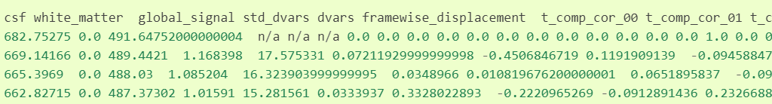

For my dataset, there are 490 rows (for the volume acquisition) and x (typically hundreds of columns) number of columns (depending on the number of regressors available). Therefore, you would enter these as covariates into your study matrices – ***so, do these need to be regressed into the individual file? Is this considered as 1st-level analysis?***

In general, you should include these common regressors in your study matrix, when running GLM: estimated head-motion parameters trans_x, trans_y, trans_z, rot_x, rot_y, rot_z - the 6 rigid-body motion parameters (3 translations and 3 rotation), estimated relative to a reference image, Global signals, such as csf - the average signal within anatomically-derived eroded CSF mask; white_matter - the average signal within the anatomically-derived eroded WM masks; and global_signal - the average signal within the brain mask (though, global signal is also contended). 2Also, would be to include outlier detection confounds (framewise_displacement, rmsd, dvars, std_vars), and band-pass filtering (cosine_xx).

Principles of fMRI – regressors / artifacts to consider removing from your rsFMRI:

<https://www.youtube.com/watch?v=gQeUQJyXirk>

Brain Voyager has a detailed explanation about temporal high-pass filtering: <https://www.brainvoyager.com/bvqx/doc/UsersGuide/Preprocessing/TemporalHighPassFiltering.html>

With the .tsv file generated from fmriprep, you will want to remove the chosen regressors out of your fMRI data. You can use several programmes and software tools for this, but I will be using the ***denoiser***, as created by the fmriprep authors as well: <https://github.com/arielletambini/denoiser>.

Also, a good resource for removing the nuisance regressors: <https://carpentries-incubator.github.io/SDC-BIDS-fMRI/05-data-cleaning-with-nilearn/index.html>

MELODIC ICA:

Andrew Jahn tutorial:

<https://www.youtube.com/watch?v=C0nDropNuiI&list=PLIQIswOrUH6_UZW1z42TA9u-vnUYzyWdA&index=1>

FSL video:

<https://www.youtube.com/watch?v=Xs_c3-neuec>

fMRI high-pass filtering:

<https://neurostars.org/t/highpass-filter-in-fmriprep/5912>

<https://neurostars.org/t/how-to-set-band-pass-filter-using-fmriprep/19137>

<https://neurostars.org/t/how-to-choose-a-proper-bandpass-filter/1700>

<https://neurostars.org/t/bandpass-filtering-different-outputs-from-fsl-and-nipype-custom-function/824>

<https://fmriprep.org/en/latest/outputs.html#confound-regressors-description>

References

Calamante, F., Masterton, R. A. J., Tournier, J. D., Smith, R. E., Willats, L., Raffelt, D., & Connelly, A. (2013). Track-weighted functional connectivity (TW-FC): A tool for characterizing the structural-functional connections in the brain. *NeuroImage*, *70*, 199–210. https://doi.org/10.1016/j.neuroimage.2012.12.054

Calamante, F., Smith, R. E., Liang, X., Zalesky, A., & Connelly, A. (2017). Track-weighted dynamic functional connectivity (TW-dFC): a new method to study time-resolved functional connectivity. *Brain Structure and Function*, *222*(8), 3761–3774. https://doi.org/10.1007/s00429-017-1431-1

Honey, C. J., Sporns, O., Cammoun, L., Gigandet, X., Thiran, J. P., Meuli, R., & Hagmann, P. (2009). Predicting human resting-state functional connectivity from structural connectivity. *Proceedings of the National Academy of Sciences of the United States of America*, *106*(6), 2035–2040. https://doi.org/10.1073/pnas.0811168106

Leonardi, N., & Van De Ville, D. (2015). On spurious and real fluctuations of dynamic functional connectivity during rest. *NeuroImage*, *104*, 430–436. https://doi.org/10.1016/j.neuroimage.2014.09.007

Raffelt, D., Tournier, J. D., Fripp, J., Crozier, S., Connelly, A., & Salvado, O. (2011). Symmetric diffeomorphic registration of fibre orientation distributions. *NeuroImage*, *56*(3), 1171–1180. https://doi.org/10.1016/j.neuroimage.2011.02.014

Shirer, W. R., Ryali, S., Rykhlevskaia, E., Menon, V., & Greicius, M. D. (2012). Decoding subject-driven cognitive states with whole-brain connectivity patterns. *Cerebral Cortex*, *22*(1), 158–165. https://doi.org/10.1093/cercor/bhr099

Tournier, J. D., Smith, R., Raffelt, D., Tabbara, R., Dhollander, T., Pietsch, M., … Connelly, A. (2019). MRtrix3: A fast, flexible and open software framework for medical image processing and visualisation. *NeuroImage*, *202*(August), 116137. https://doi.org/10.1016/j.neuroimage.2019.116137

Zalesky, A., & Breakspear, M. (2015). Towards a statistical test for functional connectivity dynamics. *NeuroImage*, *114*, 466–470. https://doi.org/10.1016/j.neuroimage.2015.03.047

**Notes:**

1. For the sliding window length, it is best to refer to (Zalesky & Breakspear, 2015). I have followed what (Calamante et al., 2017) has done in implementing a 1-minute sliding window. According to (Leonardi & Van De Ville, 2015), a good rule of thumb is to use a 100-second sliding window, as this would encapsulate the resting-state BOLD signal (and would allow less noise), in which the signal is typically above 0.1 HZ. However, it is argued that you can have shorter time windows, if your data is relatively clean and contains high SNR, with a relatively minimised false positive rate. This would help to capture the fluctuations in functional connectivity (Zalesky & Breakspear, 2015). As talked about in (Zalesky & Breakspear, 2015), some studies have reported using window lengths as short as 40 seconds long for measuring the dynamic functional connectivity in resting-state BOLD (Shirer, Ryali, Rykhlevskaia, Menon, & Greicius, 2012).
2. It is thought that global signal regression will induce a bias towards finding anti-correlations between RSNs. <https://www.youtube.com/watch?v=gQeUQJyXirk>